PRINCIPLES FOR PRINCIPALS
HANDBOOK FOR PARTICIPANTS
FACILITATOR: MINHAS TEJANI
DIGITAL PLATFORM: EDLABS
SELF ASSESSMENT:
REFLECT ON THE FOLLOWING QUESTIONS:
- WHAT IS MY ROLE AS AN EDUCATIONAL LEADER?
- WHAT ARE SOME OF MY KEY STRENGTHS AS A PERSON AND A PROFESSIONAL?
- WHAT ARE SOME KEY AREAS FOR IMPROVEMENT IN ME?
- WHAT IS MY PERSONAL VISION AND FOR MY ORGANISATION?
- WHAT ARE SOME CHANGING TRENDS OF EDUCATION AND HOW AM I EQUIPPING MYSELF TO BE AWARE OF THEM?
- WHAT DO I KNOW ABOUT MYSELF?
- HOW DO I WANT TO GROW AS A PERSON AND A PROFESSIONAL?
- WHERE DO I WANT TO SEE MY ORGANISATION IN THE NEXT 10 YEARS?
INTENTIONS FOR THE PROGRAM:
WRITE THREE INTENTIONS FOR YOUR PERSONAL DEVELOPMENT:
1)
2)
3)
WRITE THREE INTENTIONS FOR YOUR PROFESSIONAL DEVELOPMENT:
1)
2)
3)
THE WHY, WHAT AND HOW OF THE PROGRAM:
WHY:
- Principles govern the thinking of the humans as well as organizations
- Sharing of experiences of personal and professional development as an educational leader.
- Knowledge and application of what to do as well as what not to do
- Progressive approach – Three stages of development through this program
- The world is constantly changing and it has its impact on the dynamics of education system
WHAT:
5 PRINCIPLES –
PRINCIPLE 1 It’s not about changing OTHERS it’s about changing MYSELF
PRINCIPLE 2: It’s not about BEHAVIOUR change its about PARADIGM SHIFT
PRINCIPLE 3: It’s not about WHAT you do Its about WHY you do it
PRINCIPLE 4 It’s not about ORGANISATION it’s about PEOPLE
PRINCIPLE 5: It’s not about DOING it’s about BEING
OVERALL FRAMEWORK OF THE PROGRAM
THREE LEVELS:
- BASIC
- PROFICIENT
- ADVANCED
HOW:
5 MODULES
EVERY MODULE 1 PRINCIPLE IN DETAIL.
SELF PACED ON EDLABS LEARNING MANAGEMENT SYSTEM
INPUT THROUGH VIDEO LESSONS
ASSIGNMENTS AND TASKS THROUGHOUT EACH MODULE – A WORKBOOK WILL BE PROVIDED TO THE PARTICIPANT.
QUIZES AND EXERCISES FOR SELF ASSESSMENT
FINAL ASSESSMENT FOR THE AWARDING OF CERTIFICATE

DAY 1:
THE 99 CLUB:
WHAT ARE SOME ASPECTS OF YOUR LIFE THAT YOU ARE GRATEFUL FOR?

WHAT IS THE KEY LESSON LEARNT FROM “THE 99 CLUB” STORY?

THE GREATEST SHIFT IN HUMAN HISTORY:
In The 8th Habit Dr. Stephen R Covey quotes Peter Drucker while discussing the greatest shifts in human history. “In a few hundred years, when the history of our times is written from a long-term perspective, it is likely that the most important event those historians will see is not technology, not the internet, not e commerce. It is an unprecedented change in human condition. For the first time, literally, substantially and rapidly growing numbers of people have choices. For the first time, they will have to manage themselves. And society is totally unprepared for it.” (p 12).
REFLECT ON THE IDEA OF HAVING CHOICES AND MANAGING OURSELVES. HOW DOES THIS IMPACT THE EDUCATION SYSTEM?

Dr Covey further shares the 5 stages of human civilization which are:
- Hunter and Gatherer
- Agricultural
- Industrial
- Information/ Knowledge worker age
- Age of Wisdom
“The most valuable assets of a 20th Century company were in production equipment. The most valuable asset of a 21st century institution, whether business or non-business, will be its knowledge workers and the productivity. (PETER DRUCKER)
- Industrial age Paradigm People/Human = Thing
- The knowledge age Paradigm = People/Human = Whole Person.
HOW DOES THE KNOWLEDGE AGE PARADIGM INFLUENCE THE LEARNERS OF THE 21ST CENTURY? LIST SOME AREAS IN WHICH YOUR ORGANISATION IS STILL IN THE INDUSTRIAL AGE PARADIGM?

WHAT IS THE KEY DIFFERENCE BETWEEN PRINCIPLES AND PRINCIPALS?

WHAT ARE PRINCIPLES?
“Principles are ways of successfully dealing with reality to get what you want out of life.” Ray Dalio author of “Principles”
WHO IS AN EFFECTIVE PRINCIPAL?

5 CHARACTERISTICS FROM THE WALLACE FOUNDATION:
1. Shaping a vision of academic success for all students, one based on high standards;
2. Creating a climate hospitable to education in order that safety, a cooperative spirit, and other foundations of fruitful interaction prevail;
3. Cultivating leadership in others so that teachers and other adults assume their part in realizing the school vision;
4. Improving instruction to enable teachers to teach at their best and students to learn at their utmost; and
5. Managing people, data and processes to foster school improvement.

PRINCIPLE CENTRED LIVING – THREE GENERATIONS

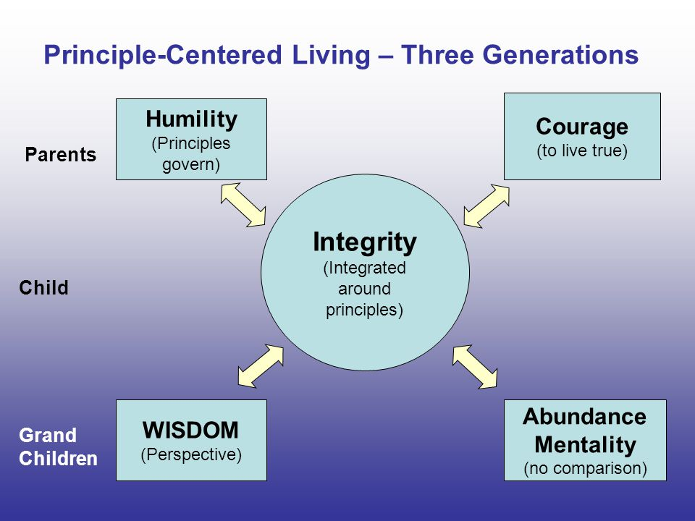

HOW DOES THE PRINCIPLE CENTRED LIVING IMPACT MY PERSONAL DEVELOPMENT?

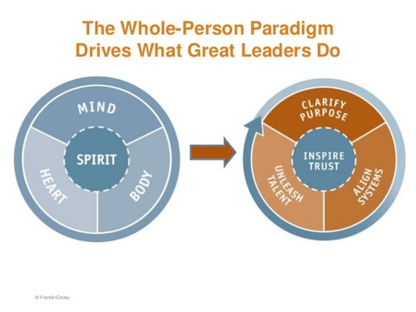
WHAT ARE SOME AREAS OF MY PERSONAL DEVELOPMENT FROM THE PERSPECTIVE OF WHOLE PERSON PARADIGM?

PRINCIPLE 1 It’s not about changing others it’s about changing myself.
REFLECT ON THE IDEA OF BEGINNING OF LIFE FROM THE OUTSIDE AND INSIDE PERSPECTIVE FROM THE EXAMPLE OF AN EGG:
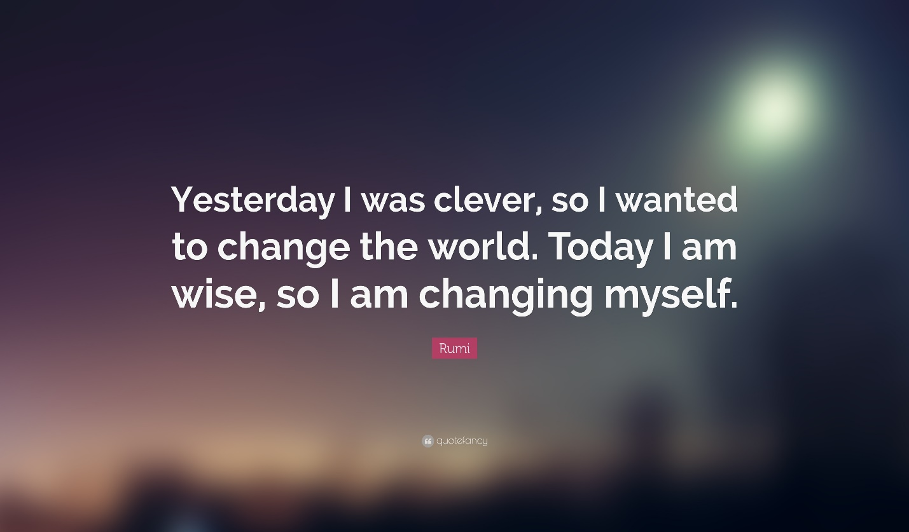
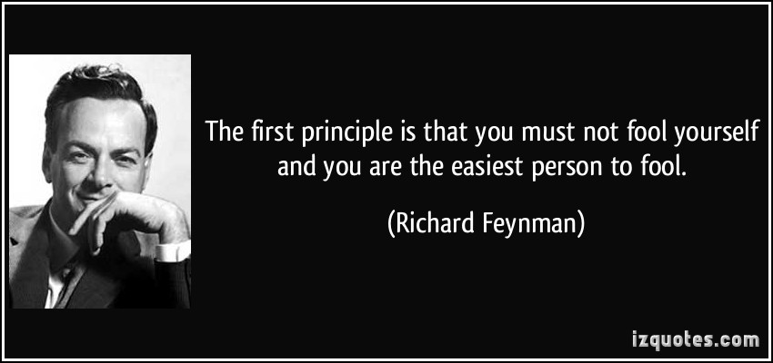
LIST SOME AREAS IN WHICH YOU HAVE BEEN FOOLING YOURSELF. PICK ONE THAT YOU CAN IMPROVE UPON.

STRATEGY 1:
OMO MEDITATION: GO THROUGH THE OMO MEDTATION PRACTICE BY THE FACILITATOR.
PRACTICE THE OMO MEDITATION ON A REGULAR BASIS
STRATEGY 2:
GRATITUDE JOUNALING:
Some guided questions
1. What are 3 things you’re thankful for today?
2. What are 5 positive things about yourself? Pick one and reflect deeply on the impact of it on your life.
3. Who are 3 people you’re thankful for today?
4. Who are 3 people you can reach out to with encouragement or a message of gratitude today?
5. What’s a place that your grateful for?

MODULE 2:
PRINCIPLE 2: ITS NOT ABOUT BEHAVIOUR SHIFT IT IS ABOUT PARADIGM SHIFT

THE SEE DO GET MODEL: STEPHEN R COVEY
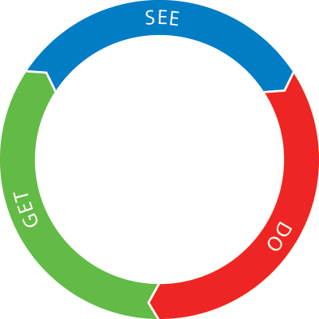
ATOMIC HABITS – JAMES CLEAR
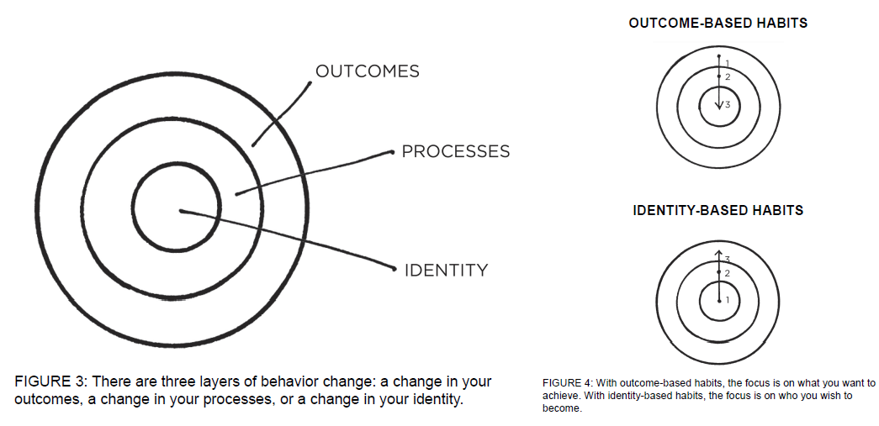
HOW ARE THE ABOVE 2 MODELS USEFUL FOR YOUR PERSONAL AND PROFESSIONAL DEVELOPMENT?

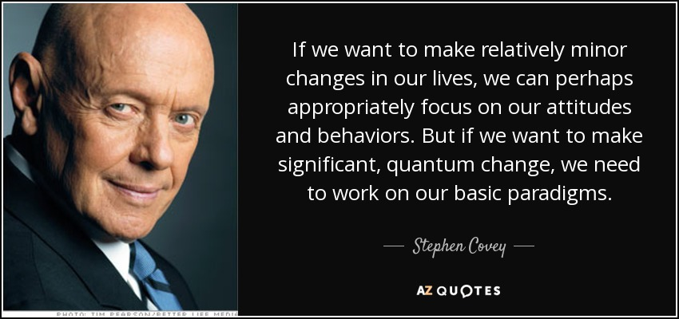

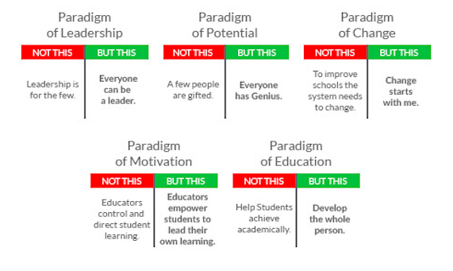

THE MATURITY CONTINUM:
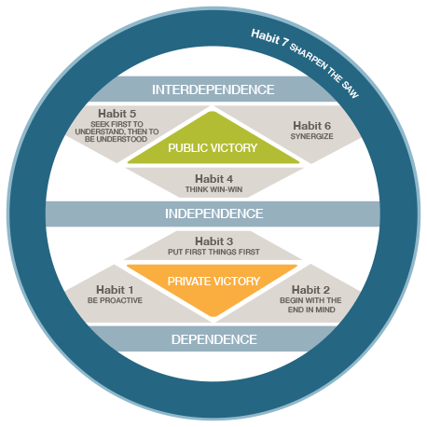
HABIT 1 BE PROACTIVE:
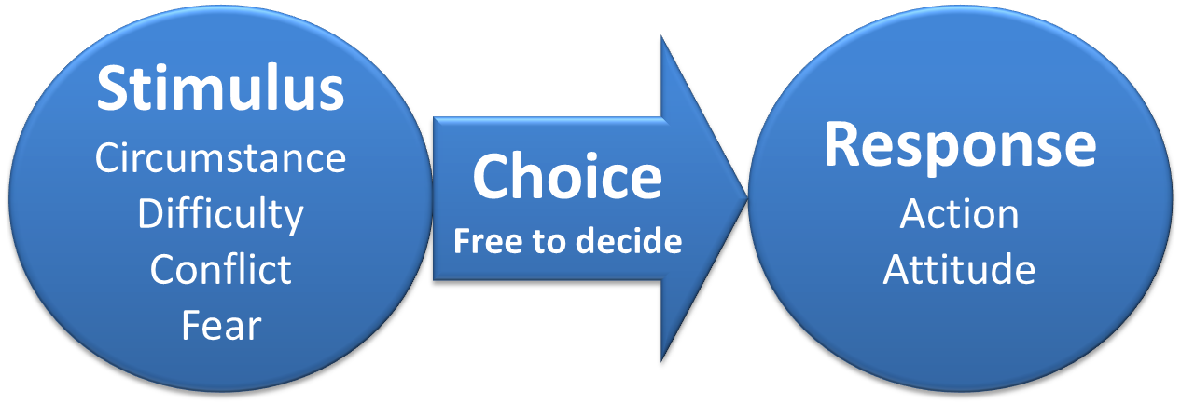
HOW CAN I BECOME A PROACTIVE LEADER?

Strategy 1: The role of language
Use Proactive Language: Think of 5 urgent tasks that are to be completed within the next 24 hours. Use the following statements:
I have to ……….
I have to ………..
I have to ………..

Then keep the same tasks in mind with a change from I have to - I choose to
I choose to ……..
I choose to ………
I choose to ……….
Strategy 2:
Listen = Silent (Seek first to Understand then to be understood)
The excerpt from The Transcendent Educator. Listen = Silent

PRINCIPLE 3: It’s not about WHAT you do Its about WHY you do it.
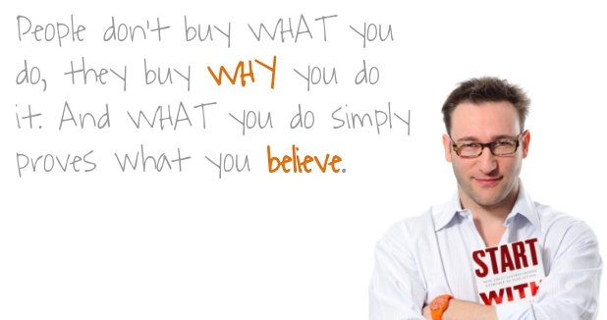
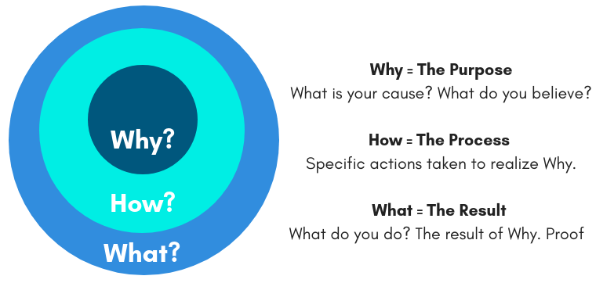

WHAT IS THE PURPOSE OF EDUCATION? WHY IS THE WHY IMPORTANT?

HABIT 2: BEGIN WITH THE END IN MIND

LISTEN TO THE VIDEO “LIVING LIFE WITH NO BARRIERS
DEVELOP A VISION FOR YOURSELF:
REFLECTIONS ON CAMBRIDGE INTERNATIONAL CONFERENCE IN 2018:
KEYNOTE SPEECH BY VALARIE HANNON
“What will ‘success’ mean in our transforming world?” ….. Given the literally unprecedented changes facing our species and our planet, we need to ask if our ideas of ‘success should change?
Her book “THRIVE”: Schools reinvented for the real challenges we face (2017)
SOME IMPORTANT FACTS TO BE CONSIDERED:
- Kai Fu Lee a pioneer in AI ( Artificial Intelligence) predicts that AI will automate and potentially eliminate 40% of jobs within next 15 years.
- With the amount of information in the world doubling every 2 years, our students must learn how to discern and synthesize information.
- Creativity is quickly becoming a differentiation between success and stagnation.
- The Workforce is looking beyond the best and brightest to the applicants who have the best grasp on soft skills, communication, critical thinking and flexibility.
To be successful in the next century, our learners must have the opportunity to, move beyond the forward facing lecture based classrooms where they simply collect information, and find their way solving difficult problems with peers where they must think deeply and creatively about content, and communicate their thought process and ideas effectively to others.” Debra Stafford
REFLECT ON THE WORDS OF WISDOM BY DEBRA STAFFORD.

STRATEGY 1:
MEANS GOALS AND END GOALS:
LISTEN TO THE VIDEO BY VISHEN LAKHIANI AND ANSWER THE FOLLOWING QUESTIONS:
- What do you want to experience in life?
- How do you want to grow and develop yourself?
- How do you want to contribute to the world?

STRATEGY 2:
Your 80th Birthday:
Imagine you are celebrating your 80th birthday. Your family and friends are surrounding you and there is a festive mood. Everyone is happy and sharing their views about you. There are smiles, claps and hugs. The delicious cake is in front of you with 80 candles on it…
What would you like them to share on your 80th birthday?
What contributions and achievements you would have made that they will acknowledge and appreciate?
What are some of your character traits that they may have cherished?

PRINCIPLE 4 It’s not about the organization it’s about people

REFLECT ON THE STORY OF THE CIRCUS LION.

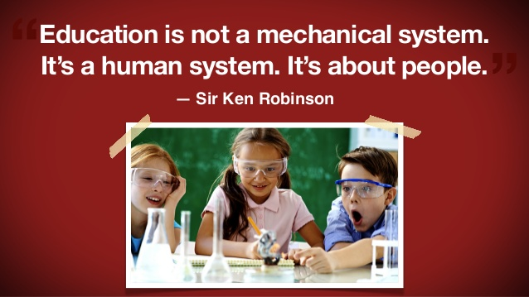
LISTEN TO THE TED TALK BY SIR KEN ROBBINSON: HOW TO ESCAPE THE DEATH VALLEY OF EDUCATION

LEARNING COMMUNITIES:

HOW CAN YOU TRANSFORM YOUR ORGANISATION INTO A LEARNING COMMUNITY?

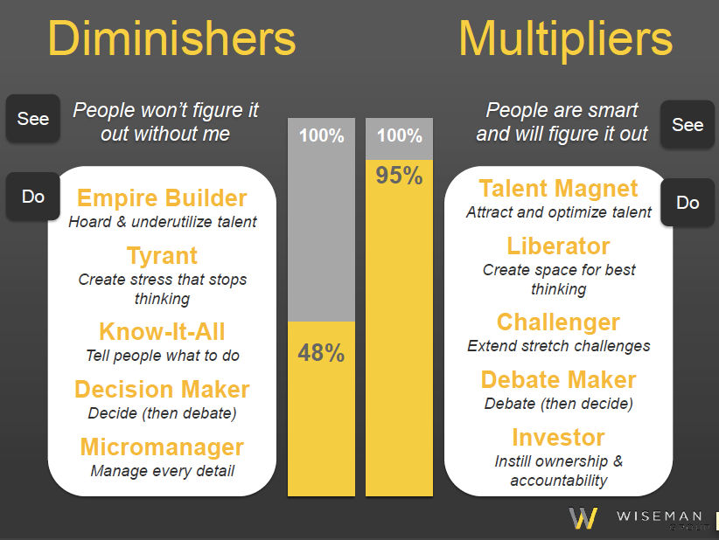
HOW CAN YOU SHIFT FROM A DIMINISHER TO A MULTIPLIER?

Strategy 1 Shift from Micromanager to Investor
Strategy 2 Shift from Decision Maker to Debate Maker

PRINCIPLE 5: It’s not about doing its about being
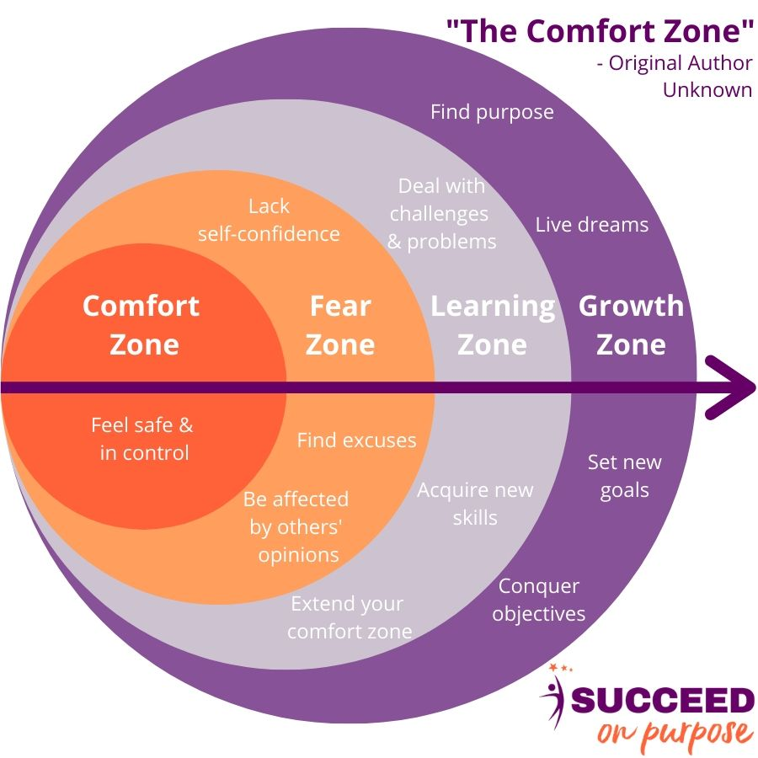
WHERE DO YOU SEE YOURSELF IN THE ABOVE FRAMEWORK?
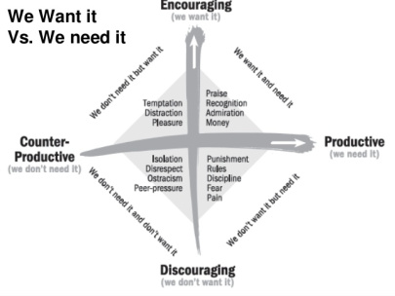
REFLECT ON ATLEAST ONE INSTANCE WHERE YOU DID NOT GET WHAT YOU WANTED AND YOU GOT WHAT YOU NEEDED.

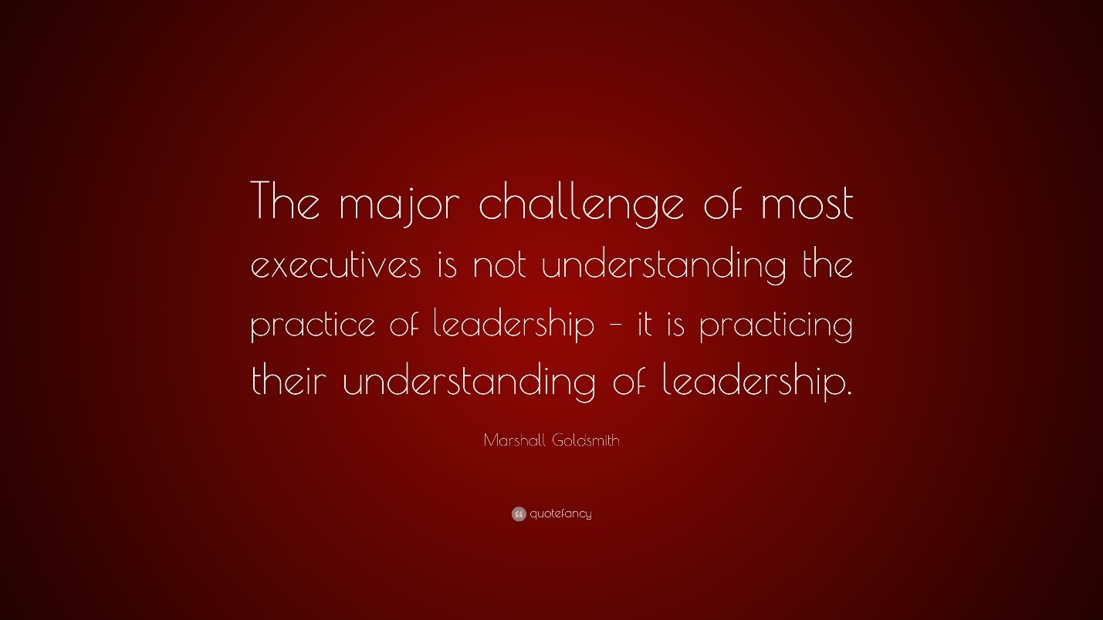

LISTEN TO THE TED TALK BY Eduardo Briceno How to get better at things you care about:
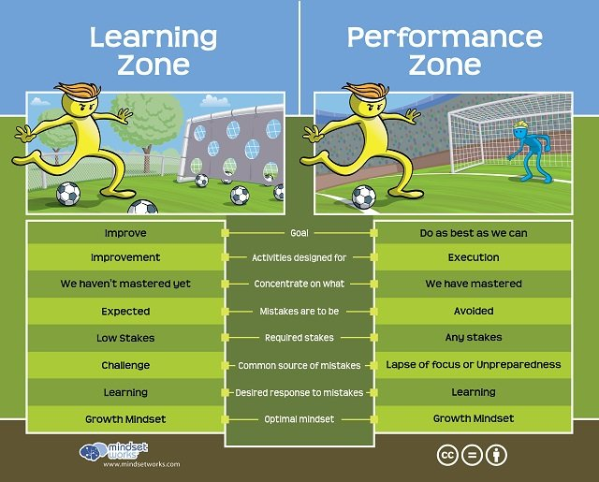

LISTEN TO THE TED TALK PROCRASTINATE ON PURPOSE BY RORY VADEN
HOW CAN I BECOME A HIGH PERFORMER?

STRATEGY 1:
ONE PAGE PRODUCTIVTY PLANNER

STRATEGY 2:
RELEASE TENSION SET INTENTION

